Project 2 B10815057

1. PLA files

input1.pla : B'CD'+ABC+A'BC+ABC'D



input2.pla : AB'CD + B'D'E + A'CD + AD + BE' + CE



1. DOT files

output1.dot:



output2.dot:





1. Screenshots

output1.png

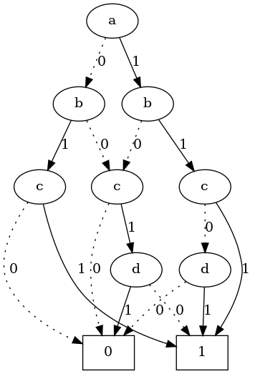

output2.png

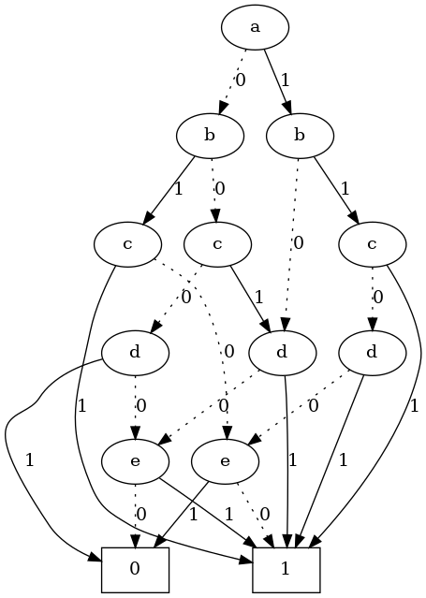

1. Source code: [gist](https://gist.github.com/frakw/8386e4b082a38437497d73c8f450248f)

